Transfer learning
🧠 What is Transfer Learning?
Transfer learning means:
👉 Using a model that already learned something, instead of starting from zero.
🖼️ In AI terms
- A model is trained on a big dataset (like millions of images)
- It already knows basic patterns:
  - edges
  - shapes
  - textures
Instead of training a new model: 👉 You reuse this knowledge for a new task.

✅ Why use Transfer Learning?
- 🚀 Faster training
- 📉 Needs less data
- 🎯 Better accuracy
- 💻 Less computing power

🧠 Very simple example
- Pre-trained model learned animals, cars, objects
- Your task: classify cats vs dogs
Instead of training from scratch: 👉 Use the pre-trained model and slightly adjust it

🔁 What do we “transfer”?
- Lower layers → basic features (edges, shapes)
- Higher layers → task-specific understanding
You decide:
- What to keep
- What to retrain

🎯 One-line definition (easy to remember)
Transfer learning = reuse an already-trained model and adapt it to a new problem.
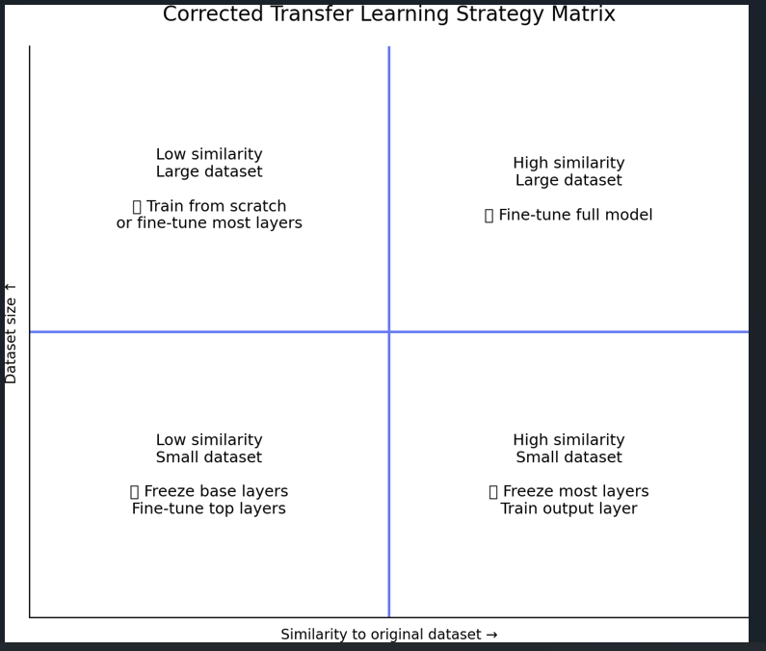
Dataset Situation | What to Do | Why
Similar + Large | Fine-tune whole model | Enough data, similar task
Similar + Small | Fine-tune last layer only | Avoid overfitting
Different + Large | Train from scratch | Old model not useful
Different + Small | Fine-tune top layers only | Limited data

Similarity | Data Size | What to Do
High | Large | Fine-tune full model
High | Small | Train output layer
Low | Large | Train from scratch
Low | Small | Train top layers only
🟦 1. High similarity + Large dataset
✅ What this means
- Your new task is very similar to the original task
- You have a lot of labeled data
Example:
ImageNet model → classify different types of animals✅ What to do
👉 Fine-tune the entire model (or most layers)🧠 Why
- Existing features are useful ✅Large data reduces overfitting risk ✅

🎯 One-line summary
“My problem is similar and I have enough data, so I can retrain the whole model.”
🟦 2. High similarity + Small dataset
✅ What this means
- Your task is similar to the original
- You have limited data
Example:
ImageNet model → classify cats vs dogs (few images)✅ What to do
👉 Freeze most layers, train only the output layer🧠 Why
- Pre-trained features already work ✅
- Small data → full training would overfit ⚠️

🎯 One-line summary
“The model already knows this task, I just adjust the final decision.”
🟦 3. Low similarity + Large dataset
✅ What this means
- Your task is very different from the original
- You have plenty of data
Example:
ImageNet model → medical X-ray images

✅ What to do
👉 Train from scratch OR fine-tune most layers

🧠 Why
- Old features are not useful ❌
- Large data allows learning new patterns ✅

🎯 One-line summary
“The old knowledge doesn’t help, but I have enough data to relearn.”
🟦 4. Low similarity + Small dataset
✅ What this means
- Your task is different
- You have very little data
Example:
Natural images → satellite or radar images (few samples)

✅ What to do
👉 Freeze lower layers, fine-tune only top layers🧠 Why
- Low-level features (edges, shapes) are still useful ✅
- Not enough data to retrain everything ⚠️

🎯 One-line summary
“Reuse basic features, adjust only high-level understanding.”
🧠 Super-Easy Rule to Remember
👉 More similarity → reuse more
👉 More data → train more

